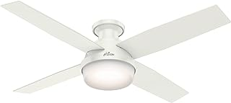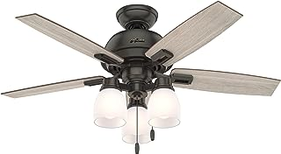

# Name: Hunter Fan Company 50272 Donegan Ceiling Fan, 44, Noble Bronze Finish

**Price:** $179.99

[**About this item**](javascript:void(0))

* Material Type: Steel Resin Aluminum Plastic Glass
* Included Components: Motor Blades Light Kit Bulbs

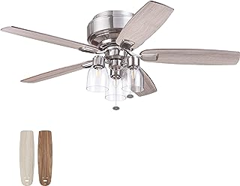

# Name: Prominence Home Magonia, 52 inch Farmhouse Style, Flush Mount LED Ceiling Fan with Light, Dimmable, Pull Chain, Dual Finish Blades, Reversible Motor - 51669-01 (Brushed Nickel)

**Price:** $164.00

[**About this item**](javascript:void(0))

* The Magonia is an industrial farmhouse ceiling fan on a traditional frame. This flush mount ceiling fan with light was crafted for both style and comfort but also designed to make installation a breeze.
* CLASSIC & TRADITIONAL COTTAGE STYLE FOR LARGE ROOMS:  With 5 fan blades and a 52” span, this flush mount ceiling fan will keep larger rooms cool, light, and airy (up to 360 square feet)
* EASY INSTALL: Our unique installation eliminates all those unnecessary screws and makes attaching the blades as simple as 1-2-3.
* FLUSH MOUNT & HIGH IMPACT:  “Hugging” the ceiling, this flush mount ceiling fan means more space underneath for furniture, activities, and whatever else makes your house feel like a home.
* TRI-LEVEL ADJUSTABLE LIGHT: Choose your lighting brightness: set the mood for a romantic dinner or host a home-schooling session...with 3 levels of varying brightness you’ll have lighting for any occasion.

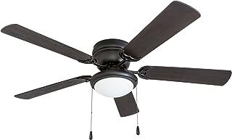

# Name: Portage Bay 50251 Hugger 52" Matte Black West Hill Ceiling Fan with Bowl Light Kit

**Price:** $69.99

[**About this item**](javascript:void(0))

* LOW CEILINGS: No problem, this ceiling fan measures 11.5 inches from ceiling to bottom of light fixture
* LIGHT: Frosted cased white light kit with 1 E26/A15 bulb. Dimmable 100% to 10% and 600 lumens (200 degree beam angle)
* 5 BLADES: Dual finish fan blades (52 inches) Matte Black on side A - Siberian Walnut on side B
* QUIET, REVERSIBLE MOTOR: Conveniently quiet, 3 speed - reversible motor. Can be run in the winter to aid in rotating warm air and cutting down on energy costs.
* WARRANTY: Limited Lifetime



# Name: Hunter Fan Company 59242 52" Dempsey Indoor Low Profile Ceiling Fan with Light, Fresh White Finish

**Price:** $153.55

[**About this item**](javascript:void(0))

* MODERN CEILING FAN: The contemporary Dempsey fan comes with LED light covered by cased white glass that will keep home interior current and inspired; Measures 52 x 52 x 12.27 Inch.Wattage 66.2 watts.Voltage 120 volts
* MULTI-SPEED REVERSIBLE FAN MOTOR: Whisper Wind motor delivers ultra-powerful airflow with quiet performance; Change the direction from downdraft mode during the summer to updraft mode during the winter
* LED LIGHT KIT: Energy-efficient dimmable LED light bulbs let you control the lighting and ambiance of the living space; The long lasting bulbs have longer lifespan than traditional bulbs
* UNIVERSAL HANDHELD REMOTE: Adjust the brightness of light and speed of the white ceiling fan with ease from anywhere in the room
* ROOM PLACEMENT: Indoor fan is designed to be used in rooms with low ceilings, the low-profile housing fits flush to the ceiling; Ideal fan for living room, lounge, bedroom, children's room and nursery
* Includes Fan/Light Universal Handheld Remote Control (White)

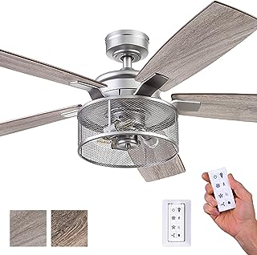

# Name: Honeywell Ceiling Fans Carnegie, 52 Inch Industrial Style Indoor LED Ceiling Fan with Light, Remote Control, Dual Mounting Options, 5 Dual Finish Blades, Reversible Airflow - 51460-01 (Pewter)

# Price:  $125.74

[**About this item**](javascript:void(0))

* RUSTIC CHIC- This beautiful ceiling fan offers such a unique aesthetic, bringing a calming warmth, yet rustic depth into the comfort of your home. We can't get enough of this look ourselves. Who says you can't bring some of the rustic-chic ambiances into your living space..
* EDISON BULBS: This beautiful copper steel mesh drum has an open light fixture showcasing 3 E26/ B10 vintage style Edison bulbs(included with purchase) giving the power to light up room but also dimmable 20%-100% to adjust to your moods. This ceiling fan is 450 lumens, 4.5 watts - 100 lumens per watt with a color temperature of 2700K
* REMOTE CONTROL INCLUDED: Controlling your fan has never been easier. The 3 speed settings of your fan as well as the light output all from the convenience of an easy-to-use remote control (included). Also compatible with Google Home and Alexa with a Bond Home (sold separately). Batteries are included
* DUAL MOUNT COMPATIBLE: This fan can be hung by the standard downrod mount, 4” downrod included, or on angled ceilings (angle bracket for angles greater than 17 degrees sold separately)
* DUAL-FINISH REVERSIBLE BLADES: The style is up to you. This ceiling fan comes with a different finish on each side of the blades. One side comes in a beautiful Rough Pine finish, while the other side showcases a lovely Gray Oak finish. Pick the look that best fits your space.

# 

# Name: DatingDay 42" Invisible Ceiling Fan Chandelier Light,Modern Crystal DIY Ceiling Fan Light Remote Control 4 Retractable ABS Blades for Bedroom Living Dining Room Decoration (42", Black)

# Price: $209.99

[**About this item**](javascript:void(0))

* 【Innovative Design 】Retractable Ceiling Fans and LED Chandelier 2 In 1,It Is Very Cost-effective.The ABS blades will stretch out and put inside automatically when turn on and off. timer setting of 1h, 2h, 4h,is available with remote control.Moreover，you can DIY the chandelier fan's shape by adjusting the down angle
* 【Color and Speed】The drop ceiling fan light includes 3 Colors Light, White Light/Neutral Light/Warm Light, It can be changed to create different atmosphere by remote control. high brightness, low power consumption and long service life.The fan speed can be adjusted by 1-6 switch
* 【Retractable Blade Design】 Retractable acrylic ceiling fan make house looks more beautiful,the fan not only make you cool in summer,and provide you decent decoration.Upgraded with forward and reverse function,forward extraction to make you cool in summer,reverse extraction to regulate air circulation in winter
* 【Durable to Use】The motor made of copper provides strong air flow and quiet performance with vents, which can reduce the internal temperature of the main unit and extend the life of the motor
* 【Silent Motor】Smart invisible ceiling fan lights with remote control glass lampshade and 4 acrylic brown blades, 6-speed switch, silent motor, no noise, don't effect the quality of sleep,when summer comes provide your cool

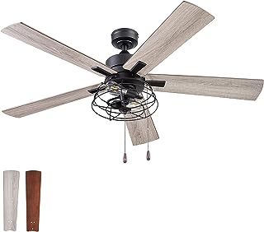

# Name: Prominence Home Marshall, 52 Inch Industrial Style LED Ceiling Fan with Light, Pull Chain, Three Mounting Options, Dual Finish Blades, Reversible Motor - Model 51457-01 (Matte Black)

# Price: $154.04

[**About this item**](javascript:void(0))

* INDUSTRIAL FARMHOUSE: WIth amazing textures, stylish Edison light bulbs and a beautiful matte black finish, the Prominence Home Marshall elevates and illuminates your indoor spaces. Having a blade span of 52 inches, this industrial fan is perfect for medium to large rooms such as living rooms, bedrooms, dens and much more.
* EDISON BULBS: This beautiful cage-inspired light has the power to light up room but also dimmable to adjust to your moods. This beautiful farmhouse ceiling fan uses two E26 / ST19 bulbs (included with purchase). This ceiling fan is 450 lumens, 4.5 watts, a color temperature of 2700K and is dimmable 10%-100%.
* EASY TO USE: Pull Chains included for quick and easy on and off adjustments. This fan is also compatible with universal ceiling fan remote controls (sold separately)
* TRI-MOUNT COMPATIBLE: Enjoy the dynamic hanging capabilities of a multi-position ceiling fan. This fan can be hung low profile where more walk-through space is required, standard with a 4” downrod (included) or on angled ceilings (angle bracket sold separately).
* CHOOSE YOUR STYLE: This ceiling fan comes with two blade colors to choose from right in the same box. Each blade is reversible, easily adjustable and ready whenever you want to freshen up the existing look or just try something new. This industrial farmhouse ceiling fan comes with a gray oak finish on one side and a bamboo finish on the reverse- the choice is yours.

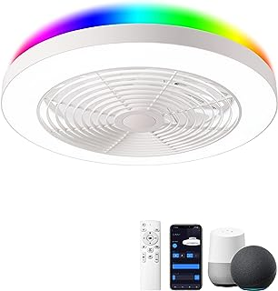

# Name: Orison Low Profile Ceiling Fan with Lights- 19.7 in Smart Bladeless ceiling fans with Alexa/Google Assistant/App Control Color Changing LED-RGB Back Ambient Light for Living Room Bedroom

**Price: $180.00**

[**About this item**](javascript:void(0))

* 【Smart APP & Voice Control】 Add smart fans light in Tuya Smart App and connect its to Amazon Alexa/Google Assistant account in 2.4Ghz network environment.Using simple voice commands to control flush mount ceiling fans with lights, such as: ● Alexa, turn on/off the light. or Alexa, turn on/off the fans ● Alexa, set the bladeless ceiling fan to 40%. Free your hands from having to find the switch and manually adjust.
* 【Dimmable & Light RGB Colors】To dim or brighten the Front White light with ALEXA or Smartphone APP of Smart Life ( IOS and Android),Intelligent LED light source can support (2700K warm light to 6500K daylight adjustment. Smart low profile ceiling fan with light can offer a great ambient rgb light whatever you want. Only 2.4GHz WIFI supported. Individually or group control. Timer and Schedule.
* 【Adjustable Fan Speed】Enclosed ceiling fan,Latest novel design With reverse function and new sleep mode:summer mode create a downward air flow,winter mode:create a upward air flow,Infinite wind speed adjustment(with remote control),the ceiling fan with lights remote control can drive the air in your room and make the air in the room more circulated,gives you powerful airflow with quiet performance.
* 【Quiet fan & memory mode】When you use the remote control to turn off the ceiling fan with lights,the next time you use the remote control to turn it on, the color temperature and brightness when it was turned off last time will remain unchanged.The low profile ceiling fan motor delivers 110V Ultra-Powerful air movement,and Factory-balanced and sound tested to ensure each blades will never wobble.
* 【 Easy to install】Instead of traditional cross hanger ,ORISON use the rotation -install base that you cna stall the lamp much easier ,Easy to remove net of the low profile ceiling fan,and cleaning it,We endeavor to provide the best quality products to our customers and value your feedback. You will enjoy a 30-day refund & return policy and a LIFETIME WARRANTY. If you have any question with the purchase, please contact us and we will be there for you.

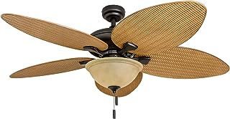

# Name: Honeywell Ceiling Fans Palm Valley, 52 Inch Tropical Indoor Outdoor Ceiling Fan with Light, Pull Chain, Three Mounting Options, 5 Palm Leaf Blades, Reversible Motor - 50507-01 (Bronze)

# Price: $142.43

[**About this item**](javascript:void(0))

* TROPICAL CEILING FAN: features a bronze finish and 5 ELT Damp rated, reversible Palmetto palm leaf/wicker fan blades. Enjoy this diverse coastal ceiling fan on porches, patios, gazebos, breezeways, garages, balcony or verandas. Installing is a breeze.
* LIGHT DETAILS: Bowl light fixture with 2 / A1 LED Bulbs / / 80 CRI - this ceiling fan comes with a no-light conversion cap if you prefer not to use the light fixture.
* TRI-MOUNT COMPATIBLE: Dynamic hanging abilities. This fan can be mounted with a down rod (standard), angled-mount (sloped) and flush-mount (4” down rod included with purchase).
* QUIET, REVERSIBLE MOTOR: Conveniently quiet, 3 speed - reversible motor. Can be run in the winter to aid in rotating warm air and cutting down on energy costs.
* MEDIUM TO LARGE SIZED ROOMS: 52 inch blade span, which are designed for medium to large sized rooms such as a bedroom, living room, dining room or common areas.
* PULL-CHAINS INCLUDED: Included for quick and easy on/off adjustments. This fan is also compatible with universal ceiling fan remote controls.

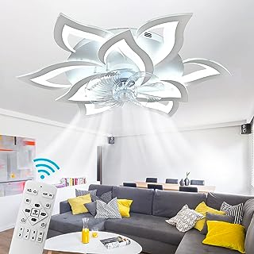

# Name: 32" Modern Ceiling Fan with Lights Remote Control, Low Profile Ceiling Fan with Lights, Flush Mount Smart Ceiling Fan Light for Bedroom Living Room Kitchen,Dimmable Lights,Reversible Blade,White

# Price: $179.99

[**About this item**](javascript:void(0))

* MODERN SLEEK LOOK & 32" Size - the smart ceiling fan wigh lights designed with 9-petal flower shape in white, adding a modern and beautiful touch to your space; 32" in maxi flower petal span fits in a room of 160-320ft, great ceiling fan light for bedroom,living room,hallway,over kitchen sink etc. NOT RECOMMENDED FOR USING IN BATHROOM
* STEPLESS DIMMING LIGHTING & 3 COLOR TEMPERATURE - Our bladeless ceilign fan featured with adjustable color temp and stepless dimming allows for adjusting the brightness of the light to your preference and changing 3 different colors on the led light from warm light (3000K) to white light (6000K) with ease
* 6-SPEED WIND & TIMMING - this flush mount ceiling fan with lights remote control designed with 6 wind speed option, just press the number 1-6 button（low, medium, high wind speeds) to adjust as your needs; 2-hour timing setting on the remote for easy controllability of this fan's woking hours
* MEMORY FUNCTION & NIGHT LIGHT MODE - when using the remote control to turn on/off this low profile ceiling fan light，which will automatically restore the light color you previously set(SWITCH CONTROL NOT SUPPORT MEMORY FUNCTION); thoughtful night light mode helps to create better sleeping environment for your family
* REVERSIBLE BLADES & ADJUSTABLE WIND DIRECTION - our flush mount ceiling fan with light includes counter-clockwise and clockwise feature to control the wind directions and air movements and allow you to keep your room cool in the summer or re-circulate warm air from the ceiling in the winter